Please read this instruction before touching the devices
The laser and driver should have the same S/N number. Don’t mismatch.

For LSR- with LSR-PS-NI
OPERATION INSTRUCTION
Install the laser by the following steps:
- Connect the laser to the driver LSR-PS-NI. Plug the connector to socket and screw on firmly.
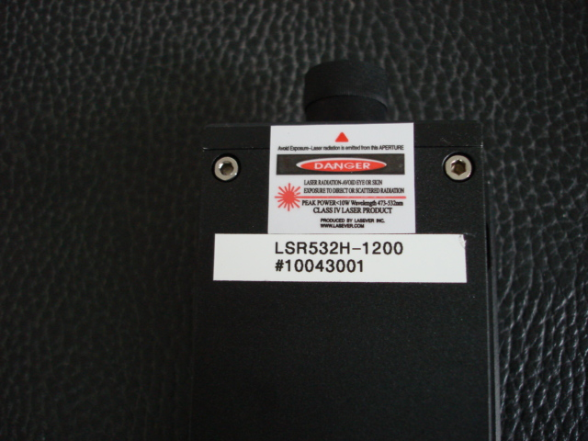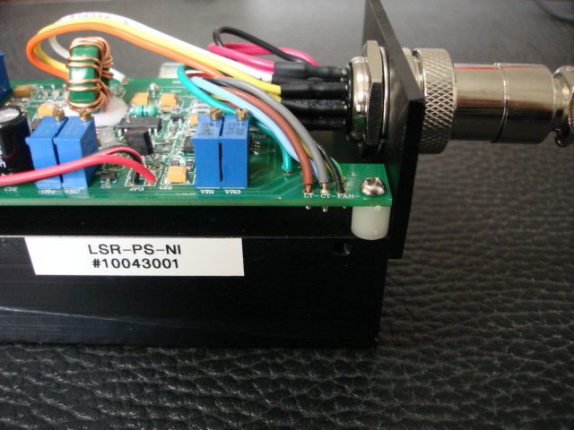
- Connect the red and black wires to LSR-PS-NI. The red wire should be connected to +5V, the black to G. Then connect the other end of the red and black wires to the 5V power supply-the red wire to +V, the black to -V. The connection should be fixed firmly.
Connect the 3 wires of the power cord to the 5V power supply correctly. The green or green/yellow double color wire is always the Ground.
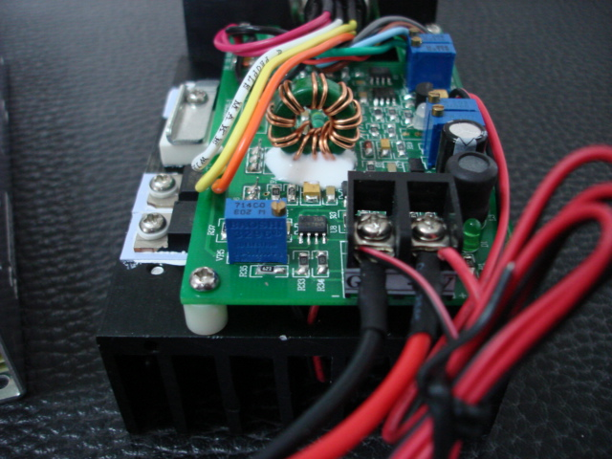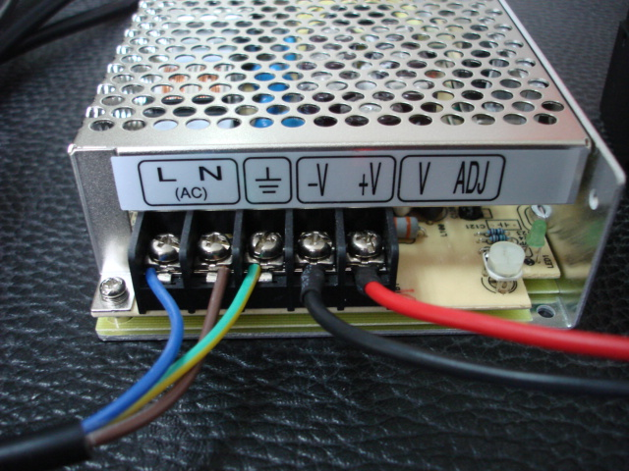

- Now the installation is completed. Plug the power cord to the wall socket and turn on the power. After 6 seconds delay the laser beam emits.
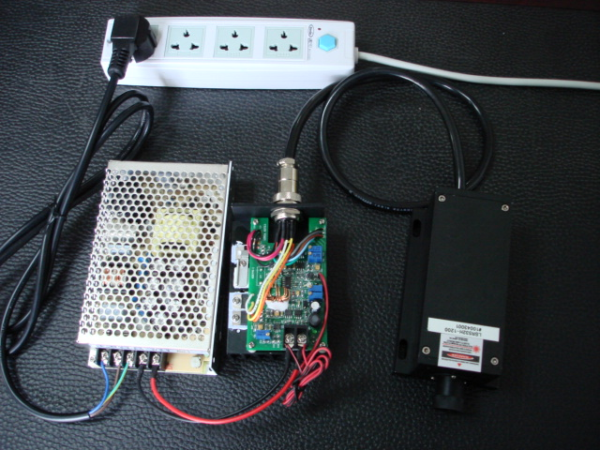

- Don’t turn on 110/220v before all wires are connected correctly. Make sure the power is off when you connect laser head to power supplies.
- When you need to turn off the laser, first to turn off the 110/220V input.

- The red and black wire from the driver is for modulation input-the black wire to 0V, the red wire to 5V. You can also connect the wires to a constant 5V for continuous operation. Don’t touch the modulation leads with hand or things with statics or high voltage when the power is on. Make connection or disconnection when power is off.
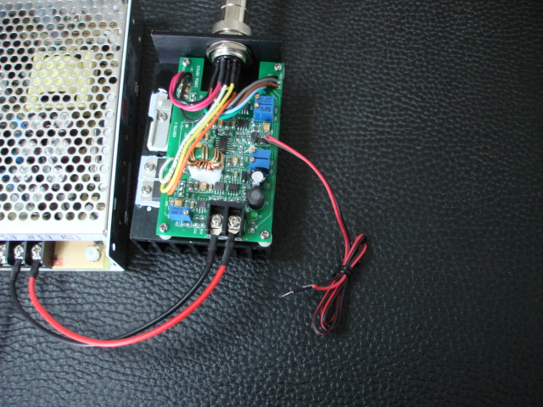

Notes:
- The bottom of laser head should be placed on a metal board or heatsink for long time operation. The power supply needs heatsink too.
- This power supply has over-hot alarm. When the temperature inside the laser gets higher than the set temperature, the power supply will turn the laser off. The red led goes on to indicate that the protection is working. You should turn off the power and add heatsink for the laser. At starting, the protection may work for a while if air temperature is higher than the set temperature.
- Don’t touch the electronic components on the LSR-PS-NI in operation.
- The laser diode may be damaged by electrostatic. Static is accumulated on body esp. in fall and winter. Antistatic wear is needed or have static discharged before close to the laser.
- Laser is harmful to human body esp. eyes. You should avoid being shot by the beam or its reflection.
One year warranty is offered to Lasever’s dpss lasers in conditions of correctly used according to this instruction. Misuse, negligence or accidents or repairs and alteration not authorized by Lasever Inc. will avoid the warranty.

Lucklaser Inc.
www.lucklaser.com

